General Description of Capstone Project

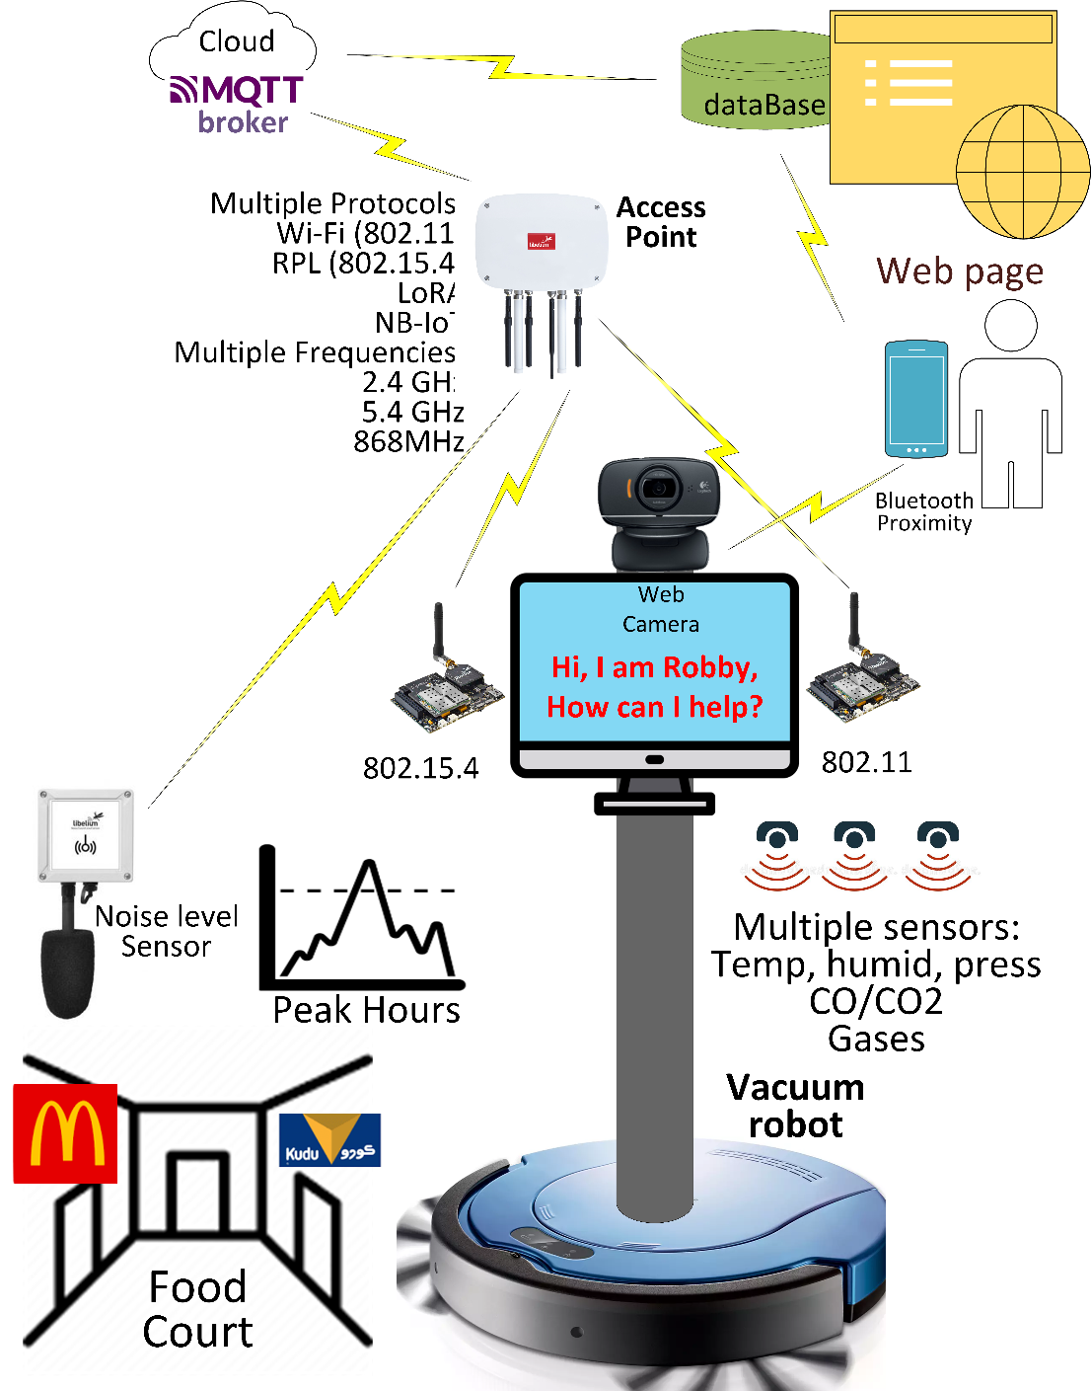Within the project, multiple environmental and ambient readings are collected from a network of multiple sensors, and dedicated equipment, communicating via multiple protocols, frequencies, and standards. The readings combined with data gathered from the interaction with the user via voice, picture, and video collected by the autonomous, intelligent machine wandering around based on an automatic vacuum, will be sent to a cloud infrastructure for further processing and decision making. Data will be depicted in a dedicated, interactive webpage, and also provided as a feed to user’s mobile application(s). Power user(s) can also interact with “Robby” via Bluetooth proximity identification. The projects aims to be continuous, and beyond the end of the current capstone project.

**TEAM MEMBERS**

Nawaf Alzahem **NA**

Fahad Aldulaigan **FA**

Mohammad Abuhaimed **MA**

Khalid Abu Alsaud **KA**

Khalid Hali **KH**

**SUPERVISOR**:

Dr. George Violettas **GV**

# Meeting #1 on Tue, 25th

|  |  |  |  |  |
| --- | --- | --- | --- | --- |
| Date and Time | October 25, 2022 | | **12:00** PM | **1:30** AM |
| Attendees | GV, KA, NA, MA, FA | | | |
|  |  | |  |  |
| **Topic Discussed** | **Action Items** | | **Expected Completion** | **Person Responsible** |
| Prepare market research on a proper hoover with an API. | | We should have a proper research document ready to propose to the university. | November, 9 | All students |
| Explore more about libellium (www.libellium.com) | | All members should have a solid grasp of the libellium libraries. | Next meeting | All students |
| Prepare design document. | | - | December, 4 | All students |
| Include the possibility of a mini PC in our market research | | We should consider the advantages and drawbacks of using a small PC. | November, 9 | All students |
| Research about libelium devices. | | All members should be familiar with the libellium catalog (for example sensores, gps tracker, and nfc) and how to connect them and implement libraries into them | Next meeting | All students |
| Explore the possibility of using mqtt broker | | We should consider the advantages that an mqtt broker would provide, as it would minimize the processing power necessary on the microprocessor itself. | Before finishing the design document | All students |

# Next Meeting → March 7 (Time 10:30)

# Meeting #2 on Tue, Nov 6th

|  |  |  |  |  |
| --- | --- | --- | --- | --- |
| Date and Time | November 6, 2022 | | **11:00** AM | **2:30** PM |
| Attendees | GV, KA, MA | | | |
|  |  | |  |  |
| **Topic Discussed** | **Action Items** | | **Expected Completion** | **Person Responsible** |
| Became familiar with IoT lab | | took a look around the lab and figured out how to connect some of the sensors. | Same meeting | GV, KA, MA |
| Packed and organized the equipment and explored most of the libelium sensors available | | organized the lab to learn more about sensors, which and how many sensors are available | Same meeting | GV, KA, MA |
| Became familiar with Waspmote IDE | | Learned how to connect sensors to Waspmote and how to push code into it | Same meeting | GV, KA, MA |
| Took a look at the example code (particularly the BME and XBEE) | | Looked at the code already prepared by GV | Same meeting | GV, KA, MA |

# Next Meeting → Nov 15, 2022

# Meeting#3 on Mon, Nov 15 in the IoT lab

|  |  |  |  |  |
| --- | --- | --- | --- | --- |
| Date and Time | Nov 15, 2022 | | **14:30** AM | **17:00** PM |
| Attendees | GV, NA, MA, FA | | | |
|  |  | |  |  |
| **Topic Discussed** | **Action Items** | | **Expected Completion** | **Person Responsible** |
| Try to figure out how mic and the reference work together to serve our implementation. | | Read the Libelium manuals and technical documents | Next meeting | NA |
| after downloading waspmote IDE, download the github code that dr.George uploaded for us on the the following links:  <http://github.com/georgevio/libelium>  <https://github.com/georgevio/libelium/capstone%20schematics> | | All students should be able to navigate and know where the code and other material is | Next meeting | ALL  students |
| figure the different sensors such as the mote and motherboard in addition to the battery and frequency band in megahertz that we already did in the lab what's the purpose of them to and how to connect it. | | Each member should create their own mote/battery combo and make it operable | Next meeting | ALL students |
| we focus how the xtce channel number and ID PAN to match with your transmitter and receiver . you control it by the waspmote code if you wanna make as transmitter or receiver by the code in connection with the access point to view the executed or uploaded packets received in the search monitor after choosing your port remember your past port is the connected port . | | figure how to manage MAC address +NET address. (meshlium) | Next meeting | ALL students |
| **Note from the supervisor:**  This is a highly applicable, hands-on project. If you don't realize that you have to spend time in the lab, with me, "get your hands dirty", you cannot continue.  Until now, most of the job is done by me, just to show you how the sensors work and collaborate, but you have to take over.  Moreover, you have to come back with ideas, suggestions, and improvements to the project. This will prove to me that you are studying, and really know what we are doing. | | | | |

# Meeting #4 on Sat, Nov 19th

|  |  |  |  |  |
| --- | --- | --- | --- | --- |
| Date and Time | November 19, 2022 | | **11:00** AM | **4:00** PM |
| Attendees | GV,KA,NA,MA,KH | | | |
|  |  | |  |  |
| **Topic Discussed** | **Action Items** | | **Expected Completion** | **Person Responsible** |
| Applying source code in github | | FULL RX_code and Full TX_code of receiving packets payload and ASCII code format (hands on). | Same meeting | ALL  students |
| Clearing memory in waspmote IDE | | learning how to clear the memory from loaded packets from the waspmote by verifying and uploading two new empty code statements. | Same meeting | ALL  students |
| Spotting packets | | the receiver are spotting the packets from the transmitter through the net address , moreover the mac address is not working properly. | Same meeting | GV and ALL  students |
| Access point sniffing | | the access point cannot identify which devices are transmitting , because MAC address is not activated. Since we are working with net address at the moment payload in addition to the values are still may not be considered valid. | Same meeting | GV and ALL  students |
| inaccurate results, date and time displaying in libelium | | the access point isn’t sniffing accurate results, date and time displaying it in the main screen through libelium. | Same meeting | GV and ALL  students |
| usability of noise level sensor in relation to the reference point of smart cities | | we are trying to figure the usability of noise level sensor that has already waspmote in it , in relation to the reference point of smart cities that has antenna sensors that acts to the sockets (to our understanding ). | Same meeting | GV and ALL  students |
| Simple Introduction to raspberry pi environment | | very light introductory raspberry pi environment by inserting a chip to the usb insert it to the usb port in computer and showing the raspberry pi image operating system. | Same meeting | GV and ALL  students |
| Discovering more about smart environments | | discovered more about smart environments device which is basically a waspmote board with a cover and long/more accurate sensors | Same meeting | ALL  students |

# Next Meeting → December 3rd

# Meeting #5 on Sat, Dec 3rd

|  |  |  |  |  |
| --- | --- | --- | --- | --- |
| Date and Time | December 3, 2022 | | **1:30 P**M | **4:30** PM |
| Attendees | GV,KA,NA,FA,KH | | | |
|  |  | |  |  |
| **Topic Discussed** | **Action Items** | | **Expected Completion** | **Person Responsible** |
| Accessed the hoover code using python.irobot.com | | Running the code to make the hoover navigate and find the charging station. | Same  meeting | ALL  students |
| Downloading ubuntu on Raspberry Pi | | Downloaded ubuntu on SD card then booting up Raspberry Pi with it. | Same  meeting | ALL  students |
| Downloading ROS 2 on Raspberry Pi | | We wanted to access ROS 2 to code the hoover using the Raspberry Pi’s ubuntu, but we are still in the login screen of ubuntu. | Next  meeting | GV and ALL  students |
| Exploring AssemblyAI voice recognition libraries | | Attempt to have the voice recognition as a working feature for the hoover. | Next  meeting | GV and KA |
| Trying to read noise level sensor | | Changed the device and microphone and we can now see it reading the noise levels | Same  meeting | GV and FA |
| Installing extra batteries | | We decided to install a few power banks inside the storage space under the hoover. | Next meeting | GV and ALL students |
| Access point sending of Meshilem from wasp mote parameters | | Manage sending information of the packets to access point instead of sniffing them or broadcast them | Next meeting | GV |

# Next Meeting → TBD IN WhatsApp group

# Meeting #6 on Wed, Dec 14th

|  |  |  |  |  |
| --- | --- | --- | --- | --- |
| Date and Time | Wednesday 14, 2022 | | **12:30 P**M | **3:30** PM |
| Attendees | GV,KA,NA,FA,KH | | | |
|  |  | |  |  |
| **Topic Discussed** | **Action Items** | | **Expected Completion** | **Person Responsible** |
| Planning to purchase Raspberry Pi 4 | | We will have to get the Raspberry Pi 4 as it is 64-bit and compatible with Ubuntu desktop that will boot ROS2. | Next meeting | ALL  students |
| Researching ROS2 compatibility with windows | | Attempting to access ROS2 directly on Windows without ubuntu. | Next meeting | ALL  students |
| Experimenting with the access points ability to identify nodes. | | To identify which wasmpote is responsible for specific packets sniffed by meshlium. | Next  meeting | GV and ALL  students |

# Next Meeting → TBD IN WhatsApp group